FALCO’S ULTIMATE GUIDE OF AWESOMENESS THAT COULD TAKE OUT A GOAT THAT U SEE IN A TUB OR SUM CRAZY GIRL THAT DOESN’T LIKE SB
HAHAHFHAHAHAHAHHFHAHHAHAHAHAHHAHAHAHAHAHAHAHAHHAH

Not really…here’s how to beat superpants v2 ^_^

LEVEL ONE:

Easy level…watch out for the plankton that goes through the walls. At the end of the world just jump off the screen, then fall onto the mountain of blocks….hit the switch get sum krabby patties. quickly jump up to the rope and climb it. Then simply make your way to the end.
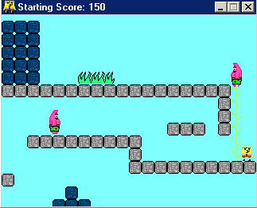

LEVEL 2:
Beware of the bubbles. Keep going straight through….once u get to the switch…beware of the pit of death…yarr…get back to the start of the level, and go down the newly opened passage…it’s a straight shot to the exit from there.

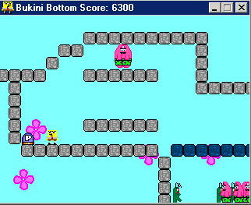

LEVEL 3:
A surprisingly easy level…just go straight…not much strategy to that. Yay.

BOSS!
You must time your jumps just right. In a couple hits…he’s fish food…yar
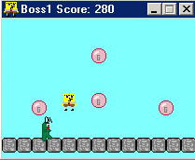

STAGE 2
LEVEL 1
A very easy level…haven’t I played this before O.o… just a straight shot to the end, watch out for the switch …make sure u don’t fall into the bubble.
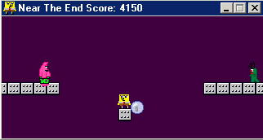

LEVEL 2

Just another straight through level…not much to do here…get to the exit…u can do it…c’mon

LEVEL 3
e-z level…except for a few bubble traps that u you should look out for…

BOSS!
Jetpack plankton…haven’t I killed this guy before…but he was in a Gary suit??
Just time your jumps right…watch out for every revolution around the room a Patrick appears…yarr
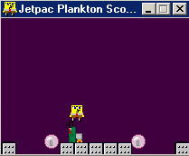

STAGE 3
LEVEL 1
Lol its hard just to time your jump over the jellyfish. Ooo and don’t forget to hit the switch at the beginning or else your in trouble later in the level…nobody likes to backtrack.

Level 2
Easy…just a straight shot whoooooooo

LEVEL 3
Watch out for bubble traps…there’s not much to this level.
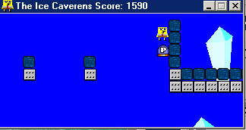
BOSS!
ROBOT PLANKTON…oooo yes he seems familiar O.o like all the bosses…just time your jumps right….

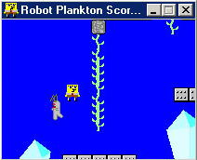
FINAL STAGE
LEVEL 1
This has allot a tuff bubble traps in it…stay with it you can do it…u can beat it…

LEVEL 2
Hard level. A LOT of Patrick’s…beware. I recommend KILLING ALL OF THEM! Then when u back track…its ez like lemon pz…whatever that means
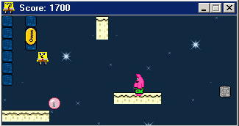…why cant I reach?!?!!?

LEVEL 3
Hard too…USE ALL THE SKILLS I HAVE TAUGHT YOU MY YOUNG PADAWONS…

BOSS!
Well…he cant be beat….yar :-( so…just hit the shift key…:-D haha
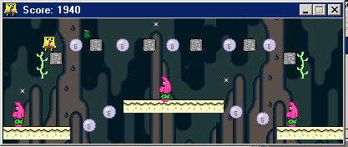
Congrats

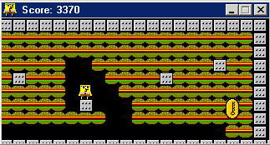
treat yourself to a krabby patty :-D

